1. First, copy the entire PyPEST folder from the shared Dropbox folder (i.e.**Dropbox/Hitchcock_Cabbage/PEST Materials)**  to your own computer.

2. If you do not already have PsychoPy, download the latest PsychoPy3 from this website:

<https://github.com/psychopy/psychopy/releases>

We are going to use PsychoPy3.0.0 for now. Scroll down till you get to **Release 3.0.0** and click the highlighted program that is highlighted in the screenshot below. Choose where you would like to save it and click Save to download.

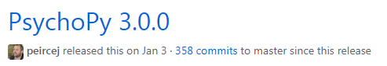

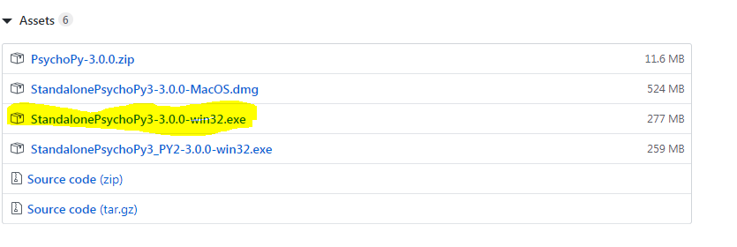

2. To open PyPEST, first open PsychoPy3 from your Start menu. There will be window that appears called “PsychoPy Coder”. You will use this window. There are two ways to open PyPEST.py:

1. Click the **Open…** icon at the top, navigate to the PyPEST folder, and click PyPEST.py.
2. Open the PyPEST folder and drag PyPEST.py to the empty gray area in the middle of the PsychoPy window.



3. Click on the round green **Run** button at the top of the window.

4. A window will pop up called Settings Menu (see screenshot below). It includes default values for the data to be used for the experiment, including file/experiment names, timing (e.g, time allowed between playing the sound and responding), and PEST information. To learn more about each setting, hover over the labels before each textbox.

*Changing stimulus pairs*

In the ***experiment/audio*** folder within PyPEST, there are four folders that contain audio for different stimulus pairs. You will need to select the pair you want to work with by changing the Stimulus Directory in the Settings menu. To do this:

a. Click the **Browse…** button in the Stimulus Directory row.

b. Click the ***experiment*** folder, then ***audio***, and finally the folder for your selected stimulus pair.

c. Click the **Select Folder** button at the bottom of the window to complete your selection.

When you click **Submit & Continue**, the experiment window will appear and you can proceed with the task.

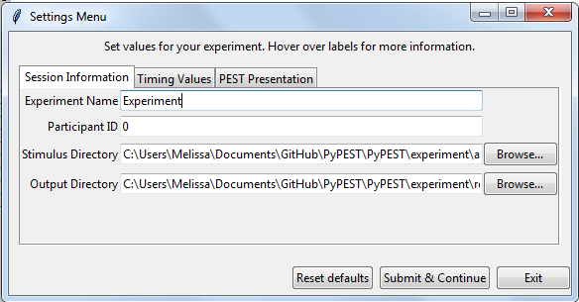

5. The program should complete itself eventually (as PEST does), but if you run into an issue, you can click the red **Stop** button at the top of the original PsychoPy window. During the experiment, you can also press the **Esc** key instead of providing a response to end the experiment.

6. To look at the results, navigate to the folder **PyPEST/experiment/results**. The name of the results file will be [experiment name]_[participant id]_results.csv.